**Experiment 5: Design User Interface**

**Title:** Design User Interface for chosen problem considering the need of society.

**Learning Objective:** Students should be able to design user interface of each module as per Society/customer requirement.

**Tools:** Figma, canva, mocplus.

**Theory:**

**Figma:** Figma is a cloud-based design tool that allows designers to collaborate in real-time. Figma offers a range of UI components such as buttons, icons, input fields, and navigation menus. Figma also has a plugin ecosystem, which allows users to access additional UI components created by other designers.

* Canvases: Canvases are the main work areas in Figma where you create your designs. You can create multiple canvases for different screens, pages, or sections of your design.
* Layers: Layers are used to organize and manage different design elements in Figma. Layers can include shapes, images, text, and other design assets. You can arrange layers by moving them up or down the stack, group them together, or lock them to prevent accidental changes.
* Frames: Frames are containers that hold specific parts of your design. You can use frames to organize your design elements and control how they are displayed. Frames can also be used to create responsive designs by setting constraints on their size and position.
* Libraries: Libraries are collections of design assets, including components, colors, and fonts. You can create and share libraries with other designers, which helps maintain consistency across different projects.
* Prototyping: Figma has built-in prototyping capabilities that allow you to create interactive designs and prototypes. You can link different canvases together, create animations, and define interactions such as hover states, clicks, and swipes.

**Canva:** Canva is a popular graphic design tool that also offers UI design capabilities. Canva offers a range of UI components such as buttons, icons, and pre-designed templates for different types of interfaces. Canva also has an extensive library of stock images and illustrations that can be used in UI design.

* Templates: Canva offers a wide range of templates for different types of user interfaces, such as websites, mobile apps, and social media platforms. These templates provide a starting point for your design and can be customized to fit your specific needs.
* Shapes: Canva offers a range of shapes that can be used to create buttons, icons, and other design elements. You can customize the shape's size, color, and style to match your design.
* Icons: Canva has an extensive library of icons that can be used to represent different actions, features, and functions in your user interface. These icons can be customized by changing their color, size, and style.
* Text: Canva's text tool allows you to create headings, subheadings, and body text for your user interface. You can choose from a variety of fonts, and colors to match your design.
* Images: Canva's image library includes a wide range of stock photos and illustrations that can be used to enhance your user interface. You can also upload your own images and graphics to use in your design.

**User Interface:**

**Login Page:**

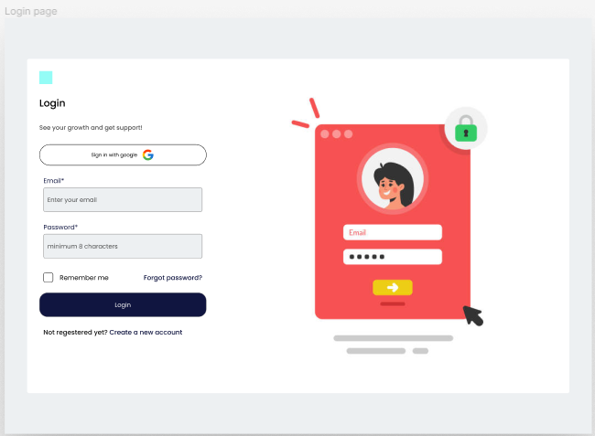

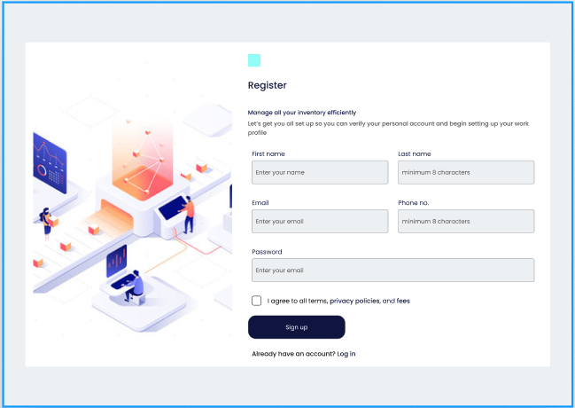**Registration Page:**

**Dashboard ( Dark Mode ):**

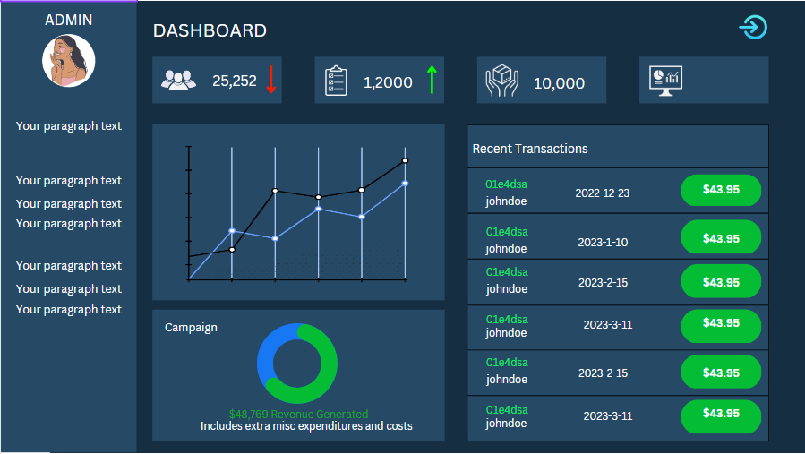

**Order Placed:**

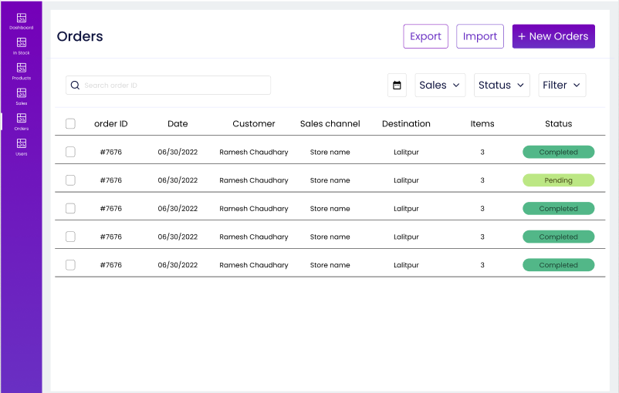

**Stock Data:**

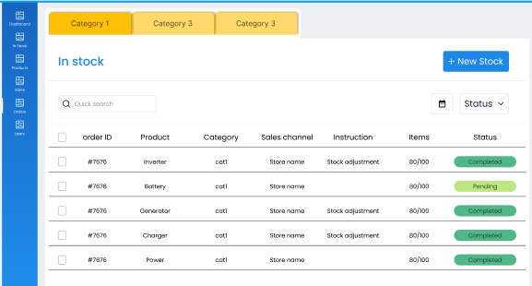

**Learning Objective:** Different tools for interface design were explored.

**Conclusion**: - In conclusion, to design an effective user interface for an e-commerce website, it is important to consider factors such as usability, functionality, aesthetics, and accessibility. The interface should be intuitive and easy to navigate, allowing customers to find products quickly and efficiently. It should also provide clear product information, including pricing, availability, and shipping details. Designing a user-friendly interface is crucial to ensure a positive shopping experience for customers.

For Faculty Use

|  |  |  |  |  |
| --- | --- | --- | --- | --- |
| **Correction**  **Parameters** | **Formative**  **Assessment**  **[40%]** | **Timely completion of Practical [ 40%]** | **Attendance /**  **Learning**  **Attitude [20%]** |  |
| **Marks**  **Obtained** |  |  |  |